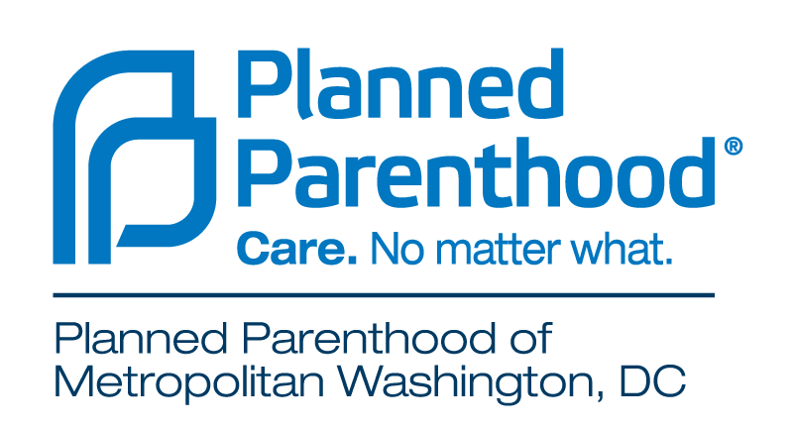
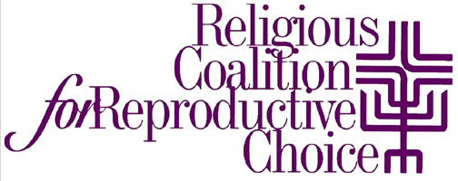

JANUARY 10, 2017

FOR IMMEDIATE RELEASE

CONTACT
Mollie Katz Mara Kaiser Braunger
Religious Coalition for Reproductive Choice Planned Parenthood of Metro Washington
202-527-9058 202-763-7361
press@rcrc.org mara.braunger@ppmw.org

Local Faith Leaders Stand with Planned Parenthood Metro Washington
Interfaith Unity Ceremony Reinforces Commitment to
Reproductive Freedom

Washington, D.C. – In an historic moment as reproductive rights and Planned Parenthood are under political attack, faith leaders celebrated an interfaith unity ceremony inside the new Washington, D.C. Planned Parenthood health center as a public stand of solidarity. Christian, Jewish, Muslim, Hindu and secular leaders joined voices to reaffirm that women should be trusted to make their own reproductive health decisions without judgment or shame.

The Washington, D.C.-based Religious Coalition for Reproductive Choice (RCRC), http://www.rcrc.org – the only interfaith national advocacy group that is pro-faith, pro-family and pro-choice – organized the event with Planned Parenthood of Metropolitan Washington, D.C., which is dedicated to providing unbiased, medically accurate, high-quality education to all communities – including communities of faith.

Co-pastors, also known as “co-equals,” Reverend Doctors Christine and Dennis Wiley of the Baptist United Church of Christ in Washington, D.C. co-officiated the blessing. Reverend Dennis Wiley said “I am here because I respect the freedom of every woman to control her own body and destiny.” Co-pastor Christine Wiley added, “As a womanist African American clergywoman, I must be here as I acknowledge my responsibility to partner with efforts of empowerment in our community, especially as it affects marginalized women of color.”

Clergy and people of faith have been explicitly and intentionally working with Planned Parenthood for over 85 years, and many clergy members remain supportive allies to Planned Parenthood.

“Jewish Tradition commands us to respect our bodies and to strive for health as a means of honoring our relationship with God. As a reflection of the fundamental Jewish belief in the importance of health, we view abortion as a personal decision between a woman, her doctor, and her faith,” said Rabbi Michael Namath, Program Director of Religious Action Center of Reform Judaism.

Patient MJ Flores gave remarks describing how “anti-choice laws made it difficult for me to access my safe and legal right to abortion…and though the stigma and shame once silenced me, I will no longer be silenced. I am not alone. You are not alone. Many of us have had abortions and we are loved.”

One in five women has come to Planned Parenthood for quality, nonjudgmental care – including women of all religious backgrounds. Attacks on access to basic reproductive health care often affect access to preventive care, including cancer screenings, birth control, STD testing and treatment, well-woman exams and more – and hit hardest the people who already face the most barriers to care.

“This powerful event is a symbolic gesture of peace, unity and spiritual healing for women in this country who have been objectified and stigmatized by their reproductive health choices. This is an incredible moment in history,” said Dr. Laura Meyers, President & CEO, PPMW.

At Planned Parenthood, we work hard to make sure people can make their own decisions about their own health care without shame, judgment, or stigma and in consultation with their doctor, their families, and their faith.

The Religious Coalition for Reproductive Choice is a broad-based, national, interfaith movement that brings the moral force of religion to protect and advance reproductive health, choice, rights and justice through education, prophetic witness, pastoral presence and advocacy.

PPMW’s mission is to provide high quality, affordable reproductive health care; promote education programs that empower all individuals to make informed and responsible reproductive choices; and to protect the right to make those choices. PPMW is the oldest and largest provider of family planning services in Metropolitan Washington, serving DC, Maryland and Northern Virginia.

###

