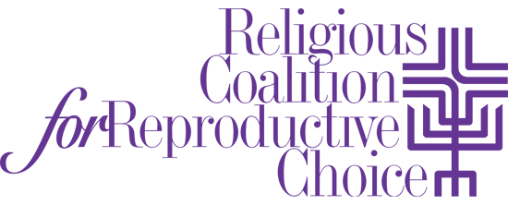

February 16, 2017

FOR IMMEDIATE RELEASE

Mollie Katz Dr. Iva E. Carruthers
Religious Coalition for Reproductive Choice Samuel DeWitt Proctor Conference, Inc.
press@rcrc.org godiva@sdpconference.info
202-527-9058

THE RELIGIOUS COALTION FOR REPRODUCTIVE CHOICE AND THE SAMUEL DEWITT PROCTOR CONFERENCE, INC. ANNOUNCE HISTORIC PARTNERSHIP

Richmond, V.A. – The Religious Coalition for Reproductive Choice (RCRC) and the Samuel DeWitt Proctor Conference, Inc. (SDPC) announce the formation of a historic partnership to advance reproductive justice in black faith communities. The two groups’ aligning of efforts marks an unprecedented collaboration between a national pro-choice religious organization and a national black religious organization to address reproductive and sexual health issues in black faith communities.

“This partnership will deepen our collective capacity to advocate and organize against the critical ways in which basic human rights of women is repressed and violated. We know the history of race and gender dehumanization of African enslaved women. We know of the proven genetic DNA experimentation and exploitation of African American, Henrietta Lacks,” as stated by SDPC General Secretary Dr. Iva E. Carruthers. “Through this partnership, the voice of Proctor and the African American faith community will continue to be unrelenting in advocating for reproductive justice for women and men.”

“The ability of black people to maintain control over their bodily autonomy is linked to the conditions in the communities where they live, and a full understanding of reproductive health and sexuality is key to healthy communities and the liberation of black bodies,” says Toni Bond Leonard, RCRC project consultant and a founding mother of the reproductive justice movement. “This partnership prayerfully and intentionally works with black faith communities at the intersection of religion and reproductive justice to unapologetically name the oppressive theologies that have silenced the discourse about black bodies and counters them by affirming and supporting the moral authority of black people to make reproductive and sexual health decisions,” says Bishop John Selders, pastor of the Amistad United Church of Christ and RCRC board vice-president.

In keeping with the theme of this year’s Samuel DeWitt Proctor Conference: Return, Remember and Renew, RCRC will be cosponsoring a pre-conference institute in which both the conference attendees and the local community can participate. Reproductive justice will be discussed in greater detail as the history of reproductive oppression of black women is examined and how it relates to what is taking place present day, nationally to locally.

The Religious Coalition for Reproductive Choice is a broad-based, national, interfaith movement that brings the moral force of religion to protect and advance reproductive health, choice, rights and justice through education, prophetic witness, pastoral presence and advocacy.

The mission of the Samuel DeWitt Proctor Conference (SDPC) is to nurture, sustain, and mobilize the African American faith community in collaboration with civic, corporate, and philanthropic leaders to address critical needs of human and social justice within local, national, and global communities. SDPC seeks to strengthen the individual and collective capacity of thought leaders and activists in the church, academy, and community through education, advocacy, and activism.
# # #

