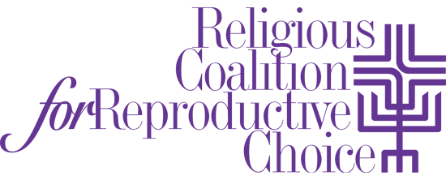

STATEMENT ON THE TRUMP ADMINISTRATION'S POLICIES
TOWARD MUSLIMS, IMMIGRANTS, WOMEN AND LGBT PEOPLE
Feb. 6, 2017

Over the past two weeks this country has been on a fast-moving train of injustice. Every day there is a barrage of policies and actions from this administration that are a gross violation of human rights.

The Religious Coalition for Reproductive Choice (RCRC) is unequivocally opposed to the attacks that have and will continue to be waged against our reproductive freedoms. Additionally, we are morally outraged by the attacks on Muslims, refugees, immigrants, people of color, women and LGBT people.

Every religious and spiritual tradition is shaped by the following golden rule: "Love your neighbors as you would yourselves." Those who are being excluded and intentionally harmed by the recent executive orders and political appointments are our neighbors. We call upon all people of faith and people of conscience to stand in solidarity with one another. We are facing an unrelenting administration whose actions have very serious consequences for whole communities of people.

The entire RCRC family expresses our deep solidarity and commitment to work for justice with all communities targeted by this administration. We call upon people of faith - and people of good will who profess no formal faith - to take action to prevent all attempts to use religion to dehumanize and divide. Our humanity is at stake and we pray for the collective fortitude it will require for us to resist being overtaken with fear or weariness as we continue to work towards justice for all.

The Religious Coalition for Reproductive Choice (www.rcrc.org) is a broad-based, national, interfaith movement that brings the moral force of religion to protect and advance reproductive health, choice, rights and justice through education, prophetic witness, pastoral presence and advocacy.

